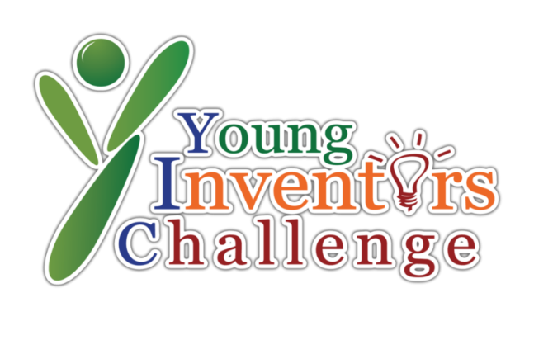

Country
State
School Name
Team Name
Pitch Video Link

Team Members Name

Team Mentors Name

Report Preparation Guidelines
(To be removed before convert to PDF file)
Please follow the instructions below when preparing your report for the Young Inventors Challenge (YIC). These guidelines ensure fairness and consistency during the evaluation process.

- Maximum Length: Your report must not exceed 5 pages.
- The cover page, table of contents, and appendices (such as the AI usage declaration and references) do not count toward the 5-page limit.
- Paper Size: Use A4 paper size.
- Font: Use Times New Roman, with a font size of 12 points.
- Line Spacing: Set line spacing to 1.0 (single spacing).
- File Format: Save and submit your report in PDF format.
- AI Usage: You must follow the AI/Technology Usage Policy provided by YIC. A declaration of any AI tools used must be included in the appendices.
Table of Contents
1.0 Problem Statement 4
2.0 Relevance to the Theme 4
3.0 Description of Invention 4
4.0 Scientific Principle Relevant to the Invention 4
5.0 Originality 4
6.0 Diagram with Specifications and Technicality 4
7.0 Benefits of the Invention/innovation 4
8.0 Conclusion and Future Projects 5
APPENDICCES 6
Appendix A: References 7
Appendix B: AI Usage Declaration 8
Appendix C: Supporting Documents 9
Appendix D: Additional Diagrams / Charts / Tables 10
Appendix E: Invention Picture (Details) 11
Appendix F: Invention Development Gantt Chart 12
Appendix G and so on (if any) 13

1.0 Problem Statement
Write a short, clear, and focused explanation of the real-world problem your invention aims to solve. Make sure the problem is specific, relatable, and relevant to the community or environment. Avoid long explanations—keep it concise and highlight why this issue needs a solution. This section should directly set the stage for why your invention matters.

2.0 Relevance to the Theme
Explain how your invention relates to the United Nations Sustainable Development Goals (SDG). Clearly state which SDG(s) your project supports (such as Clean Energy, Good Health, or Climate Action) and describe how your invention helps to achieve that goal. Show the connection between the problem you chose and the SDG it addresses. Keep the explanation meaningful and aligned with the theme.

3.0 Description of Invention
Describe the purpose and objective of your invention. Explain what it is, what it does, and how it works. Use simple and clear language so that anyone can understand. Mention the key features or functions and how users will interact with it. This section should help the reader quickly understand the invention’s design and usefulness.

4.0 Scientific Principle Relevant to the Invention
Explain the scientific concepts or principles that make your invention work. These can be based on topics from physics, chemistry, biology, or other science subjects you’ve learned. Describe how the principle is applied in your invention—for example, energy transfer, filtration, reaction, force, or motion. Use simple examples or comparisons to explain if needed.

5.0 Originality
Explain what makes your invention new or different from existing solutions. Describe the unique idea, design, or feature that makes your project stand out. Clearly state that the invention is original and not copied or plagiarized. Justify your invention by mentioning how you developed the idea or how it improves something already available.

6.0 Diagram with Specifications and Technicality
Insert a neat and clearly labelled main diagram of your invention in this section. In the explanation, describe the invention’s technical structure and how each part functions. Include important specifications like measurements, materials, or power source. Explain your testing method, if any, and point out data or results, ideally in simple tables or charts. If there are extra technical diagrams, table, or charts, refer to them by saying: “See Appendix [X], page [Y].”

7.0 Benefits of the Invention/Innovation
Describe the main benefits your invention provides. Explain how it helps the target users, solves the identified problem, and supports the selected SDG. Be specific - mention whether it saves time, is eco-friendly, cost-effective, easier to use, or more efficient than other solutions. Focus on how your invention makes a real positive impact.

8.0 Conclusion and Future Projects
Summarize your invention by linking it back to the problem and SDG discussed earlier. Compare your invention with existing ones and explain what makes yours better or more suitable. Then suggest how your invention could be improved, expanded, or used in other areas in the future. Mention the practicality, possible upgrades, or how it could be scaled for larger impact.

APPENDICCES

Appendix A: References

Appendix B: AI Usage Declaration

AI USAGE DECLARATION FORM
Declaration of Artificial Intelligence (AI) and Technological Tool Usage

Team Details
Team Name: _____________________________
Project Title: _____________________________
Institution/School: _____________________________

Declaration of AI Usage
Please provide specific details below:
AI Tool / Technology Used | Purpose of Use | Extent of Human Input
Example: ChatGPT | Used for research on market trends and refining report structure. | Final content revised and rewritten by team members.

We understand and acknowledge the following:
- AI was only used to support tasks such as brainstorming, grammar checking, research assistance, data analysis, and design visualization.
- AI was not used to fabricate data, plagiarize, or fully generate our proposal/report without substantial human involvement.
- We accept that failure to disclose AI usage or misuse of AI tools may lead to disqualification or point deduction, as per YIC rules.
We affirm that the majority of the content, ideas, and innovation presented in our project are original and developed through our own effort, under the guidance of our mentor.

Signatures
Name | Role | Signature | Date

Appendix C: Supporting Documents

Appendix D: Additional Diagrams / Charts / Tables

Appendix E: Invention Picture (Details)

Appendix F: Invention Development Gantt Chart

Appendix G and so on (if any)

